St. Paul’s Beacon ST. PAUL’S BEACON
St. Paul’s Episcopal Church
16457 Old Frederick Road,
Mt. Airy, MD 21771
410-489-4411
July/August 2020
Mark Your Calendars
Sundays, in July and August, 9:00 a.m. Service ~ Zoom and Facebook from St. Paul’s.
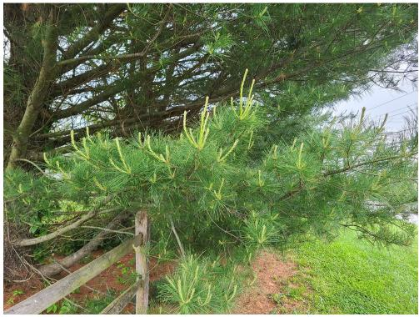
Pentecost & Dandelions - An Odd Couple
I love pine trees. In some small part because they remind me mostly of being “up north” whether back in my home state of Michigan, or Vermont where I spent some summers, or even today in the Adirondacks where I now spend some summers.
But mostly, I suspect, it is because I love the way they look, smell, and sound when the wind blows through their branches. So on my daily walks it is grand fun to pass by a few pine trees in my own neighborhood.
One day I noticed that there was wonderful new growth. It was quite stunning. Which got me to thinking.
I think, sometimes, with the presence of this virus, it is hard to think about growth and possibilities. Everything is so stymied and constrained. I feel restrained because I actually am!
But this pine tree reminded me that new growth is intrinsic to God’s creation and, therefore, us too. So now I am actually thinking more optimistically. That no matter how pervasive and difficult this virus is, there will be new growth and new possibilities that will arise.
We have already learned about a new way to worship. We continue to care for one another. We are using Zoom to great avail for meetings and education and prayer. We are still finding ways to have important community conversations. And we are still reaching out into the community and continuing to care for our neighbors.
AND I am actually hopeful that the expansive activity regarding the role of racism in our nation is of such clarity and conviction that we might make some HUGE strides toward the Kingdom of God – now.

So an odd couple – a virus and a pine tree. But together an important spiritual reminder. God is our Creator. Just look around. Summer is a grand time to be reminded that God is always creating and bringing new life forth. And God will continue to do so right now.
I am feeling my faith steadier, my trust more consistent, and my hope more outrageous – just as I want yours to do so as well.
So a blessed summer of a renewed spiritual grip for us all, as well as a time of some spiritual joy at what is possible. As we often say
God is good.
All the time God is good. — Flo Ledyard, Rector

St. Bartholomew’s Baltimore

St. Paul’s Regathering – First Update

The Diocese has asked Churches to begin preparing for regathering. St. Paul’s has a regathering committee, and we met for the first time via Zoom after Church Sunday, June 28, 2020.
There are six members of the Regathering Committee:
  - Bill Toole
  - Kathleen Alexander
  - Wendy Gahm
  - Phyllis Weston
  - Lee Hajek
  - Jeff Spaulding

Regathering will be a gradual, systematic process as mandated by the Bishop. It will happen in a systematic fashion, and there is literally a checklist of criteria which must be met and approved by the diocese before we return to traditional worship.

The front two rows will be blocked off for broadcast equipment, and every other row will be out of service. We are looking at two people per row or a family unit to allow social distancing. The Church will have to be sanitized between services, and the bathroom sanitized between users. This likely WON’T be a huge burden, and some of the committee members would be willing to take care of this. Sanitizing the Church might be done as a more thorough cleaning by the Sexton once per week. Attendance will likely be limited to about 25 people; this should not be especially burdensome. One singer/cantor is permitted, but cannot be within 20 feet of anyone else while singing. They might address this by singing in the parish hall through an open door. Services will continue to be broadcast, and at least initially, we anticipate having perhaps six parishioners in attendance (beyond the people assisting in the service) while the service is broadcast to everyone else. Hand sanitizing on entry and wearing masks will be expected.

The Thrift Shop not only provides revenue to the Church, but provides an important public service, especially during difficult financial times. On July 18, 2020, some members of the Regathering committee will look at what might be required. We anticipate wearing masks for all users; sanitizing hands at entry; asking people to go through in an orderly fashion, rather than milling about; and screening on entry. A scanning thermometer has been acquired for this purpose, for example.

Services outdoors are being contemplated as a safer supplement to indoors services. The virus is believed to spread best indoors, in confined spaces and close proximity.

Updates will be published, but feel free to contact Bill Toole at (410) 707-9412 or via email at WilliamToole1960@gamil.com; or any other committee member for additional detail or commentary.
William Toole

OUR NEW SIGN!
Many thanks to Jeff Spaulding and Pete McIntosh for creating this wonderful sign to show the community that we are alive! Stay tuned for the Thrift Store sign!
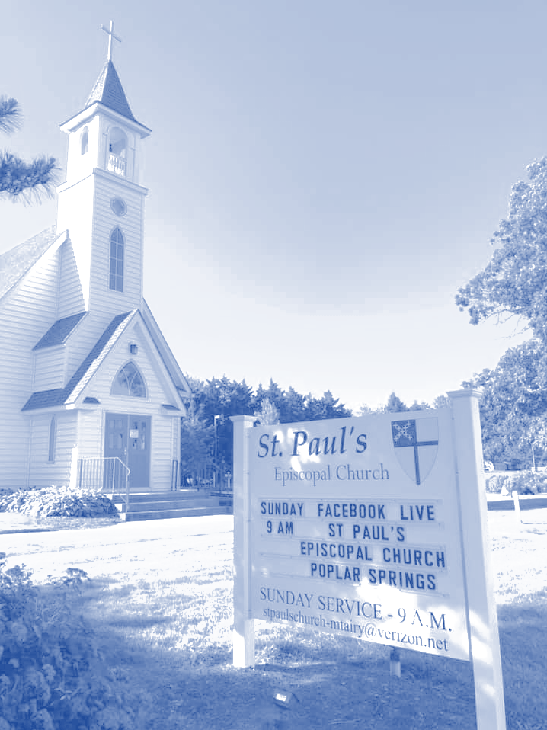

Mulching day at St. Paul’s
Many thanks to everyone who came out to refresh the church grounds with mulch! It took less than 3 hours thanks to the many hands, and Jeff and Pete’s leadership!
Pete McIntosh, Jeff Spaulding, Wendy & Steve Gahm, Ron Alexander, Dick Wilcher, Lynda & Mike Sheckels, Travis Earp

Stewardship
Thank you for your continuing financial support during this period of uncertainty due to COVID-19. The Sunday service (via Zoom) and church work and bills are still on their usual schedule. It is very important for all of us to keep our pledges up to date. Even though we are not physically meeting, other donations you may wish to make, in thanksgiving, memory, or other designations will be listed in the appropriate bulletin. We know that it is the occasion, not the flowers, you want to acknowledge. We appreciate those of you who have been giving faithfully.
Pledge Payment Options
- Mail checks to St. Paul’s. Please remember to including any special offerings building fund, and flower/altar/other donations, in addition to your pledge or regular contribution.
- Payments can be made through the Diocese.
Directions: go to www.episcopalmaryland.org
On home page - click on “Give to My Congregation”
Scroll down to St. Paul’s, Mt. Airy. Put in pledge/donation amount
Fill in bottom of the form. Click on submit payment.
Your name/pledge/donation will be sent to St. Paul’s. As usual, St. Paul’s will properly record your financial gift. Linda S. Sharp

Stewardship and Scrip: Summer is here we are out and about more often. We all have to buy groceries, get gas, go to the pharmacy etc., wearing our face mask, for your convenience Scrip is available. This is an important way to help St. Paul’s financially. Contact Pete McIntosh by phone, 410-984-3363 or email, pjmacin@aol.com, to place an order. The challenge to buy at least $100 worth of gift cards each month is still on. So during this troublesome time perhaps you can double this amount. Thanking you in advance for your support. Peter McIntosh, Chair.
My, how are garden grows!
Thanks to Wendy and Steve Gahm for providing for summer bounty. God Bless you.
Due to the green thumbs of Wendy & Steve, St. Paul’s vegetable garden is in full bloom. All of their hard labor has produced great results. Harvesting is up to us. Visit the garden and help yourself. Help yourself to organic goodness and it is free. Feel free to share with neighbors.
St. Paul’s People on the Ground.
Even as the church building continues to be closed, the parish outreach is still open. Please remember to hand out St. Paul’s business cards at every opportunity. And to invite others to join us on Zoom 9:00 a.m. Sundays or anytime on Facebook. With our feet on the ground (or by actual mail) advertise the Good News! If you need extra business cards let the church office know and they will be mailed to you.

St. Paul’s a Wealth of Talent!
Stephen Jones has come the rescue and saved the day. Not on a white horse, but almost. The computer – our life line – decided it was tired, perhaps needed a rest from daily activity, so it went on vacation. Stephen has spent many hours working to resolve said computer issues. St. Paul’s is sincerely thankful to Stephen for solving the problem. It is good to have a resident techy. St. Paul’s is blessed by the skills, talent and dedication of Stephen. Thank you Stephen.

One Lord, One Faith, One Baptism
Mostly by Zoom: A celebration and a rejoicing in the formal bonding of life in Christ through Baptism of Zowie Yejide Everage. July 5th was a bright sunny day. Radiance to match the sun was embodied in Zowie Yejide’s loving family. How wonderful to hear the voice of Nina Simone singing “Take Me to the River” while gazing upon family photos of Zowie- 9 months of precious memories. The lovely “In the Palm of My Hand” written by a friend of Doris Wilcher, was perfect for the occasion. “O Living Water Refresh my Soul” indeed was a balm of holy melody. The invention of the steel pan (a musical instrument) speak to new creation and spirit. And to the spirit of a peoples ingenuity. Father Bill’s homily welcoming Zowie Yejide and inviting all of us to live into our Baptismal Covenant is a confirmation of God’s love everyday. All Blessings and Grace upon the Barnes/Everage family and St. Paul’s Parish.

A Life Well Lived
“Come now and look upon the works of the Lord, what awesome things He has done on earth.” Psalm 46:9
Ever so often we are privileged to know people who are awesome. They seem to personify in some way a purposeful life. A way of living that recognizing stewardship and compassion. Erin Sharp was one of those people. St. Paul’s heartfelt condolences go to the Sharp and Spaulding families. We are grateful to the families for sharing a bit of Erin’s life with us via the link sent to the parish family. We have the blessed assurance of knowing that Erin is resting in the eternal embrace of God.

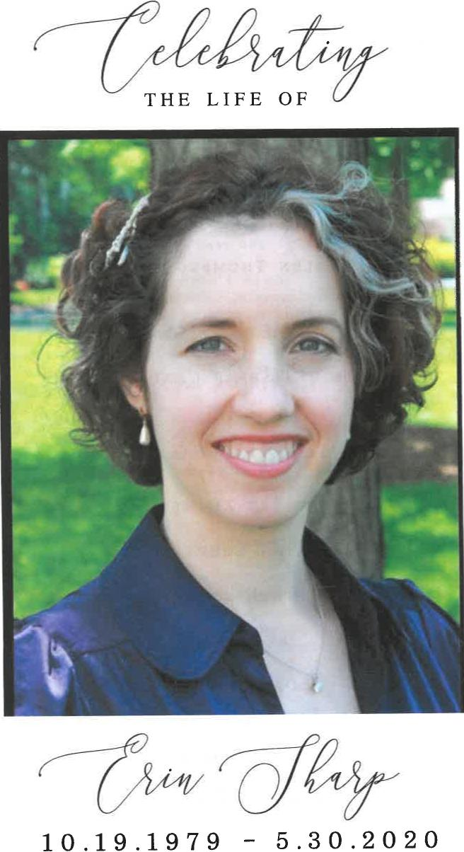
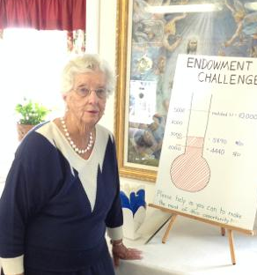
St. Paul’s History
Our time of slowed activity and limited social contact has caused many to pause and reflect on life’s meaning and purpose. Polly Moore would like St. Paul’s to refocus on its history. Polly lead the effort to write our history several years ago. Recently, Kathleen Alexander has done extensive research on the “Names” on each window in the nave. The busyness of life and the current distractions have curved these efforts. However they have not been forgotten. Once St. Paul’s returns to a new normal research and discovery will move forward in a more fully compensative manner. Therefore if you have research skills or just a love of history stay tuned for future opportunities to join Polly and build an archive for reference now and as a legacy for future generations

YOU ARE THE VITALITY OF ST. PAUL’S:
NOW, more than before, we ask you to review and meditate on the vitality of our parish. The members of your Long-Term Planning Committee for St. Paul’s have come to understand that God is resurrecting the church community into new life. We see this as part of the life-cycle of this living organization. The committee members have discovered this through prayer, reflection, personal stories and discussion. On December 8th, during coffee hour, Fr. Bill facilitated the discussion as to where St. Paul’s is, right now, on the Life Cycle Chart. At the Annual Meeting a written report of this committee was presented. Please re-read it. Then, with fresh eyes, answer the following questions again.
Where/how are you finding joy at St. Paul’s? Where/how are you finding purpose here? Where/how are you finding your connection to God at St. Paul’s? Are your answers the same as they were before when you were asked these questions; or are they different? Perhaps, now, having more time at home, you can jot down your answers and revisit them with new lenses as we move through unsettle and yet hopeful times.
May those of our parish who have entered into eternal life now know the full empowerment of the Spirit, especially Erin Sharp and may her family and loved ones know your consolation. Come, Holy Spirit.)

Upcoming Events
Sundays in July/August:
Church Service, 9:00 a.m., via Zoom and Facebook.
St. Paul’s Nearly New Thrift Shop:
Thrift Shop closed till further notice due to COVID-19
Please hold on to your donations till we are back in business. Thank you.

Happy Birthday to:
Susan Kelley July 05
Etta Lee Spaulding July 09
Trudi Lawson July 12
Mi-Ling Jones July 14
Al Yeater July 21

Happy Anniversary to:
Stephen & Mi-Ling Jones July 02
Ron & Linda Sharp July 26
William Toole & Phyllis Heffner August 25

Lord, Hear Our Prayers.
Especially now, we need to pray for All. Please call or send a note to those who are shut-in.
This month St. Paul’s would like to honor a parishioner with notes and or calls. For the month of July Etta Lee Spaulding has been selected. Please let her know you are thinking and praying for her during the month.
Her address is
Ms. Etta Lee Spaulding
7200 Third Ave. #0-402
Sykesville, MD 21784
Her phone # is (home) 410-549-8489
(cell) 410-409-7653

Prayer List
If you have additions/deletions to the prayer list please call or email the Parish Office.
Nancy McIntosh; Sandra & Stanley Napier; Gerlinde Phlaumer-Yeater; Natalie Gahm; Trudi & Dave Lawson; Bryan Landry; Terri Coates; Susan; Pam; Trish; Ruth; Joe; Sandra; Bill; Phyllis Heffner, Susan Kelley, Jaxon & Nathan Buckley, Doris Sharp; Jean Ellen, Chris Tuel, and the Sharp family.
Prayer for Healing
Jesus, with just one touch from your Almighty creative hand, You have healed the sick and raised the dead. How amazing is your Lordship over all the earth, How powerful is your redeeming love. How great was your sacrifice to go before us and bring forgiveness and hope.
By your stripes I ask for healing. Standing within your reign and rule I ask for restoration.
May life and wellness grow in fullness until it overflows. Amen.

Pastoral Concerns
Pastoral issues and concerns are important to us. Please contact the church office,
(410) 489-4411, email: stpaulschurch-mtairy@verizon.net

Vestry Officers & Members
Jeff Spaulding: Senior Warden
Pete McIntosh: Junior Warden
Treasurer: Linda Sharp
Registrar: Nancy McIntosh
Wendy Gahm William Toole
Kathleen Alexander Stephen Jones
Suzanne Bourg Phyllis Weston

MISSION STATEMENT
Our Mission is: To carry the good news of Jesus Christ into the community by word and deed and to help all people experience God’s presence in their daily lives.

St. Paul’s “A Shining
Light in the Community

Prayer List Request Form
Please help us to refresh our prayer list! Take a minute to list those people that you want included on the list and mail to the parish office.
For 3 months_____________ Prayers requested for:________________________________
Long-term _____________ Submitted by: ______________________________________
Date Submitted_____________________________________

July 2020 ~ SERVICE CALENDAR

 | July 5,  5th Sunday after Pentecost  Green  With Baptism | July 12,  6th Sunday after Pentecost  Green | July 19,  7th Sunday after Pentecost  Green | July 26,  8th Sunday after Pentecost  Green
 | 9:00 A.M. | 9:00 A. M. | 9:00 A. M. | 9:00 A.M.
Lector  Lesson 1 | --- | Ron Alexander | Kathleen  Alexander | Helen Tuel
Lector  Lesson 2 | Stephanie Stith | Pete McIntosh | Ron Alexander | Bill Toole
Psalm | Hilary Barnes | Lee Hajek | Nancy McIntosh | Ron Alexander
Prayers of the People |  | Linda Sharp | Dick Wilcher | Lee Hajek

August 2020 ~ SERVICE CALENDAR

 | August 2,  9th Sunday after Pentecost  Green | August 9,  10th Sunday after Pentecost  Green | August 16,  ^{11h} Sunday after Pentecost  Green | August 23,  12th Sunday after Pentecost  Green
 | 9:00 A.M. | 9:00 A. M. | 9:00 A. M. | 9:00 A.M.
Lector  Lesson 1 | Zowie Barnes | Dick Wilcher | Kathleen Alexander | Phyllis Heffner
Lector  Lesson 2 | Dick Wilcher | Stephen Jones | Ron Alexander | Pete McIntosh
Psalm | Ginny Chandler | Norma Prentice | Nancy McIntosh | Jeff Spaulding
Prayers of the People | Bill Toole | Lee Hajek | Helen Tuel | Linda Sharp

