NOVEMBER 2020

Sunday | Monday | Tuesday | Wednesday | Thursday | Friday | Saturday
1  All Saints’ Day  Student/Military addresses due | 2 | 3 | 4 | 5 | 6 | 7
8  23rd Sunday after Pentecost | 9 | 10 | 11 | 12 | 13 | 14
15  24th Sunday after Pentecost | 16 | 17 | 18 | 19 | 20 | 21
22  Last Sunday after Pentecost | 23 | 24 | 25 | 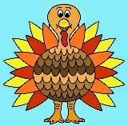  26  Thanksgiving | 27 | 28
29  First Sunday of Advent  Student/Military Items due for boxes | 30  Mailing student/ military boxes | 1 | 2 | 3 | 4 | 5

Notes :
No Senior Lunch until further notice.

