January 2022

Sunday | Monday | Tuesday | Wednesday | Thursday | Friday | Saturday
26 | 27 | 28 | 29 | 30 | 31 | 1
2  2nd Sunday of Christmas | 3 | 4 | 5 | 6 | 7 | 8
9  1st Sunday after Epiphany | 10 | 11 | 12 | 13 | 14 | 15
16  2nd Sunday after Epiphany  Bishop Ihloff Visit | 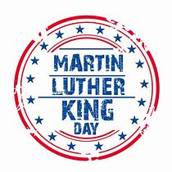  17 | 18 | 19 | 20 | 21 | 22
23  3rd Sunday after Epiphany | 24 | 25  Building & Grounds Meeting  3:30 p.m. | 26  Barbara Stevens Celebration of Life | 27 | 28 | 29
30  4th Sunday after Epiphany  Barbara Stevens  Memorial Service | 31 | 1 | 2 | 3 | 4 | 5

Notes :

