St. John’s Episcopal Church
Kingsville, Maryland
Welcomes You

Our Mission Statement

St. John’s Episcopal Church is committed to serving God and the
community, through our faith in Jesus Christ, by welcoming all,
worshiping, witnessing and continuing God’s work in the world.

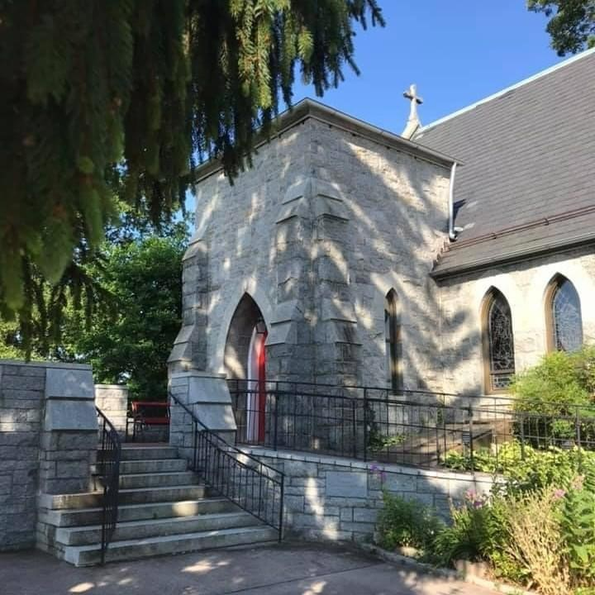
Sixth Sunday of Easter
May 9, 2021
10:30 am, Rite II
St. John’s Episcopal Church

11901 Belair Road, P. O. Box 187, Kingsville, MD 21087
FaceBook: St. John’s Episcopal, Kingsville, MD
Email: office@stjohnskingsville.org
Website: www.stjohnskingsville.org
Church Phone: 410-592-8570
Pastoral Emergencies: 410-698-5376

Church Staff

Rector: The Rev’d Elizabeth Sipos, M.Div.
Administrative Assistant: Angie Bosley
Organist/Choir Director: Nancy Heinold

The Vestry

Class of 2022 Class of 2023

John Frost Marguerite Lobb
Barb Daniel John Riley

Officers
Michele Lozanski—Sr Warden Jacob Johnson—Jr. Warden
Elizabeth Healey—Treasurer Anne Leland-Registrar

Parish Committee Chairpersons

Altar Guild: Liz Healey
Hospitality Hr. Coordinator: Barb Daniel
Outreach: Pat Carden
Organ Restoration Committee: Nancy Heinold
Chapel Restoration Committee: Jacob Johnson

10:30 am Worship
Holy Eucharist, Rite Two

10:25 am Church Bell is Rung

The Word of God

Opening hymn: We plow the fields, and scatter Hymnal #291
Cantor: Ty Schwenk

Celebrant: Alleluia. Christ is risen. BCP 355
People: The Lord is risen indeed. Alleluia.

Celebrant: Almighty God, to you all hearts are open, all desires known, and from you no secrets are hid: Cleanse the thoughts of our hearts by the inspiration of your Holy Spirit, that we may perfectly love you, and worthily magnify your holy Name; through Christ our Lord. Amen.

The Gloria in excelsis
Cantor: Ty Schwenk

Glory to God in the highest,
and peace to his people on earth.

Lord God, heavenly King,
almighty God and Father,
we worship you, we give you thanks,
we praise you for your glory.
Lord Jesus Christ, only Son of the Father,
Lord God, Lamb of God,
you take away the sin of the world:
have mercy upon us;
you are seated at the right hand of the Father:
receive our prayer.

For you alone are the Holy One,
you alone are the Lord,
you alone are the Most High
Jesus Christ,
with the Holy Spirit,
in the glory of God the Father. Amen.

Celebrant: The Lord be with you.
People: And also with you.
Celebrant: Let us pray.

The Collect of the Day Kneel as able
O God, you have prepared for those who love you such good things as surpass our understanding: Pour into our hearts such love towards you, that we, loving you in all things and above all things, may obtain your promises, which exceed all that we can desire; through Jesus Christ our Lord, who lives and reigns with you and the Holy Spirit, one God, for ever and ever. Amen.

A Reading from the Acts of the Apostles 10:44-48
While Peter was still speaking, the Holy Spirit fell upon all who heard the word. The circumcised believers who had come with Peter were astounded that the gift of the Holy Spirit had been poured out even on the Gentiles, for they heard them speaking in tongues and extolling God. Then Peter said, "Can anyone withhold the water for baptizing these people who have received the Holy Spirit just as we have?" So he ordered them to be baptized in the name of Jesus Christ. Then they invited him to stay for several days.

Reader: The Word of the Lord.
People: Thanks be to God.

Psalm 98
1 Sing to the Lord a new song, *
for he has done marvelous things.
2 With his right hand and his holy arm *
has he won for himself the victory.
3 The Lord has made known his victory; *
his righteousness has he openly shown in the sight of the nations.
4 He remembers his mercy and faithfulness to the house of Israel, *
and all the ends of the earth have seen the victory of our God.
5 Shout with joy to the Lord, all you lands; *
lift up your voice, rejoice, and sing.
6 Sing to the Lord with the harp, *
with the harp and the voice of song.
7 With trumpets and the sound of the horn *
shout with joy before the King, the Lord.
8 Let the sea make a noise and all that is in it, *
the lands and those who dwell therein.
9 Let the rivers clap their hands, *
and let the hills ring out with joy before the Lord,
when he comes to judge the earth.
10 In righteousness shall he judge the world *
and the peoples with equity.

A Reading from the First Letter of John 5:1-6
Everyone who believes that Jesus is the Christ has been born of God, and
everyone who loves the parent loves the child. By this we know that we love the children of God, when we love God and obey his commandments. For the love of God is this, that we obey his commandments. And his commandments are not burdensome, for whatever is born of God conquers the world. And this is the victory that conquers the world, our faith. Who is it that conquers the world but the one who believes that Jesus is the Son of God?

This is the one who came by water and blood, Jesus Christ, not with the water only but with the water and the blood. And the Spirit is the one that testifies, for the Spirit is the truth.

Reader: The Word of the Lord.
People: Thanks be to God.

Gradual hymn: O Love of God, how strong and true Hymnal #455
Cantor: Ty Schwenk

The Gospel
Priest: The Holy Gospel of our Lord Jesus Christ according to John 15:9-17

People: Glory to you, Lord Christ.
Jesus said to his disciples, “As the Father has loved me, so I have loved you; abide in my love. If you keep my commandments, you will abide in my love, just as I have kept my Father’s commandments and abide in his love. I have said these things to you so that my joy may be in you, and that your joy may be complete.

“This is my commandment, that you love one another as I have loved you. No one has greater love than this, to lay down one’s life for one’s friends. You are my friends if you do what I command you. I do not call you servants any longer, because the servant does not know what the master is doing; but I have called you friends, because I have made known to you everything that I have heard from my Father. You did not choose me but I chose you. And I appointed you to go and bear fruit, fruit that will last, so that the Father will give you whatever you ask him in my name. I am giving you these commands so that you may love one another.”

Celebrant: The Gospel of the Lord.

People: Praise to you, Lord Christ.

The congregation is seated.

Sermon Rev. Elizabeth Sipos+

The Nicene Creed BCP 358
We believe in one God,
the Father, the Almighty,
maker of heaven and earth,
of all that is, seen and unseen.

We believe in one Lord, Jesus Christ,
the only Son of God,
eternally begotten of the Father,
God from God, Light from Light,
true God from true God,
begotten, not made,
of one Being with the Father.
Through him all things were made.
For us and for our salvation
he came down from heaven:
by the power of the Holy Spirit
he became incarnate from the Virgin Mary,
and was made man.
For our sake he was crucified under Pontius Pilate;
he suffered death and was buried.
On the third day he rose again
in accordance with the Scriptures;
he ascended into heaven
and is seated at the right hand of the Father.
He will come again in glory to judge the living and the dead,
and his kingdom will have no end.

We believe in the Holy Spirit, the Lord, the giver of life,
who proceeds from the Father and the Son.
With the Father and the Son he is worshiped and glorified.
He has spoken through the Prophets.
We believe in one holy catholic and apostolic Church.
We acknowledge one baptism for the forgiveness of sins.
We look for the resurrection of the dead,
and the life of the world to come. Amen.

Prayers of the People Form VI BCP 392
Litanist: In peace, we pray to you, Lord God.

Litanist: For all people in their daily life and work;
People: For our families, friends, and neighbors, and for those who are alone.

Litanist: For this community, the nation, and the world;
People: For all who work for justice, freedom, and peace.

Litanist: For the just and proper use of your creation;
People: For the victims of hunger, fear, injustice, and oppression.

Litanist: For all who are in danger, sorrow, or any kind of trouble;
People: For those who minister to the sick, the friendless, and the needy.

Litanist: For the peace and unity of the Church of God;
People: For all who proclaim the Gospel, and all who seek the Truth.

Litanist: For Most Rev’d. Justin Welby, Archbishop of Canterbury; for The Most Rev’d. Michael Curry, our Presiding Bishop; for Right Rev’d. Eugene Sutton, our Bishop; for the Rt. Rev’d Robert Ihloff, our Assisting Bishop, for our Rector,
Rev. Elizabeth Sipos, for the Wardens, Vestry, Staff, and all members and friends of St. John’s Church.
People: For all who serve God in his Church.

Litanist: For the special needs and concerns of this congregation.

The People may add their own petitions

Litanist: Hear us, Lord;
People: For your mercy is great.
Litanist: We thank you, Lord, for all the blessings of this life.

The People may add their own thanksgivings

Litanist: We will exalt you, O God our King;
People: And praise your Name for ever and ever.

Litanist: We pray for all who have died, that they may have a place in
your eternal kingdom.

The People may add their own petitions

Litanist: Lord, let your loving-kindness be upon them;
People: Who put their trust in you.

Litanist: We pray to you also for the forgiveness of our sins.
People: Have mercy upon us, most merciful Father; in your compassion forgive us our sins, known and unknown, things done and left undone; and so uphold us by your Spirit that we may live and serve you in newness of life, to the honor and glory of your Name; through Jesus Christ our Lord. Amen.

Celebrant gives Absolution.

*The Peace BCP 360
Celebrant: The peace of the Lord be always with you.
People: And also with you.

Welcome & Announcements

The Holy Communion

Offertory anthem: How great thou art (Bell Choir)
Offertory hymn: Lord make us servants of your peace Hymnal #593
Doxology
Cantor: Ty Schwenk (sings both hymn and Doxology)

THE GREAT THANKSGIVING: Eucharistic Prayer B BCP 367
Celebrant: The Lord be with you.
People: And also with you.
Celebrant: Lift up your hearts.
People: We lift them to the Lord.
Celebrant: Let us give thanks to the Lord our God.
People: It is right to give him thanks and praise.

Preface of the Day

Celebrant: Therefore we praise you, joining our voices with Angels and Archangels and with all the company of heaven, who for ever sing this hymn to proclaim the glory of your Name:

Sanctus
Cantor: Ty Schwenk

Celebrant: We give thanks to you, O God, for the goodness and love which you have made known to us in creation; in the calling of Israel to be your people; in your Word spoken through the prophets; and above all in the Word made flesh, Jesus, your Son. For in these last days you sent him to be incarnate from the Virgin Mary, to be the Savior and Redeemer of the world. In him, you have delivered us from evil, and made us worthy to stand before you. In him, you have brought us out of error into truth, out of sin into righteousness, out of death into life.

On the night before he died for us, our Lord Jesus Christ took bread; and when he had given thanks to you, he broke it, and gave it to his disciples, and said, "Take, eat: This is my Body, which is given for you. Do this for the remembrance of me."

After supper he took the cup of wine; and when he had given thanks, he gave it to them, and said, "Drink this, all of you: This is my Blood of the new Covenant, which is shed for you and for many for the forgiveness of sins. Whenever you drink it, do this for the remembrance of me."

Therefore, according to his command, O Father,

Celebrant and People: We remember his death, We proclaim his resurrection,
We await his coming in glory;

Celebrant: And we offer our sacrifice of praise and thanksgiving to you,
O Lord of all; presenting to you, from your creation, this bread and this wine.

We pray you, gracious God, to send your Holy Spirit upon these gifts that they may be the Sacrament of the Body of Christ and his Blood of the new Covenant. Unite us to your Son in his sacrifice, that we may be acceptable through him, being sanctified by the Holy Spirit. In the fullness of time, put all things in subjection under your Christ, and bring us to that heavenly country where, with St. John and all your saints, we may enter the everlasting heritage of your sons and daughters; through Jesus Christ our Lord, the firstborn of all creation, the head of the Church, and the author of our salvation.

Celebrant: By him, and with him, and in him, in the unity of the Holy Spirit all honor and glory is yours, Almighty Father, now and for ever. Amen.

And now, as our Savior Christ has taught us, we are bold to say,

Our Father, who art in heaven,
hallowed be thy Name,
thy kingdom come,
thy will be done,
on earth as it is in heaven.
Give us this day our daily bread.
And forgive us our trespasses,
as we forgive those
who trespass against us.
And lead us not into temptation,
but deliver us from evil.
For thine is the kingdom,
and the power, and the glory,
for ever and ever. Amen.

Invitation to Communion

The Breaking of the Bread
Celebrant: Alleluia. Christ our Passover is sacrificed for us;
People: Therefore let us keep the feast. Alleluia.
Celebrant: The Gifts of God for the people of God.

Communion hymn: God is love, and where true love is Hymnal #577
O love that casts out fear Hymnal #700
Cantor: Ty Schwenk

The Post Communion Prayer BCP 365
People: Eternal God, heavenly Father, you have graciously accepted us as living members of your Son our Savior Jesus Christ, and you have fed us with spiritual food in the Sacrament of his Body and Blood. Send us now into the world in peace, and grant us strength and courage to love and serve you with gladness and singleness of heart; through Christ our Lord. Amen.

Blessing

Closing hymn: All creatures of our God and King Hymnal #400
Cantor: Ty Schwenk

The Dismissal
Celebrant: Let us go forth in the name of the risen Lord. Alleluia, Alleluia.
People: Thanks be to God. Alleluia, Alleluia!

Serving Today

Celebrant & Preacher: Rev. Elizabeth Sipos+
Reader: Michele Lozanski
Prayers of the People: Liz Healey
Music Director: Nancy Heinold
Cantor: Ty Schwenk
Bell Choir: Karen Smith-Manar, Nanci Rosendale,
Rev. Elizabeth Sipos, Elizabeth Healey, John Stevens,
Janine Stevens, Ty Schwenk and Camy Schwenk

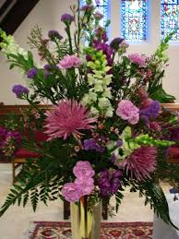
Altar Flowers

Given to the Glory of God
by The Peeling Family
in honor of First Responders

St. John’s Parish Prayer List

Additions and corrections may be made to our Parish Prayer List at any time. All names will be
automatically removed from the Parish Prayer List on the 1st Sunday of each month unless you request otherwise. Please contact Angie at <office@stjohnskingsville.org> or
410-592-8570 in the church office with all changes by 10 am Thursdays. Thank you.

We Pray for Those in Need:

Ivan, Lillian Jane (young child-Leukemia), Suzanne Estock, Lisa, Peter, Colin Germond, Sarah
Sutherland, Melissa Heaver, Liz Rawl, Ricky Carter, Marilyn Stephenson, Charlotte Williams (1 yr old), Dottie Atkin, Cleo Collins, Jean Kraft, Joannene Maynard, Mike Kellogg, Sid & Joan Pyle, Karen Sugden, DeMarino Family, Samantha, Jim, Christina, Pat, Jenny, Lisa, Debbie Grau, Marie Dilworth and Bishop Tom Corston.

We Pray for our Homebound

Lily John, Barbara Miller, Nancy Barnhart, Robin Dilworth

We pray for the Church and the World:

For Most Rev’d. Justin Welby, Archbishop of Canterbury; for The Most Rev’d. Michael Curry, our Presiding Bishop; for Right Rev’d. Eugene Sutton, our Bishop; for the Rt. Rev’d Robert Ihloff, our Assisting Bishop, for our Rector, Rev. Elizabeth Sipos, for the Wardens, Vestry, Staff, and all members and friends of St. John’s Church.

For the leaders of all nations, especially for Joseph, our President; for Larry, our Governor; for Brandon, Nick, John and Barry, who lead our City and Counties. We pray for all children and youth; for the homeless, the unemployed, and the hungry. We pray for the safety of our loved ones and friends serving in the Armed Forces at home and abroad, and for our enemies, that all our hearts may be turned toward peace throughout the world.

